# Manage friendlist

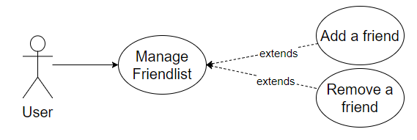

## Characteristic Information

|  |  |
| --- | --- |
| Goal: | The user is able to add new friends or to remove current friends. |
| Precondition: | In order to add a friend the user needs to know the friend tag-number to add him/her.  To remove a friend he/she has to be in the friendlist. |
| Postcondition: | The user added a friend or he/she removed an existent friend. |
| Involved User: | The user and the friends |
| Triggering Event: | The user wants to have a new friend or he/she wants to remove an existent friend. |

This usecase is devided by two subusecases

## Scenario for the standard use

| Step | User | Activity |
| --- | --- | --- |
| 1 | User | Log in |
| 2 | User | Click the “+”-button to add a friend |
| 3 | User | Type the tag-number |
| 4 | User | Select a friend |
| 5 | User | Click the “Remove”-button to remove the selected friend |
| 6 | User | Confirm the removal |

## Workflow

## Open Points

-Spamming